Vendor Oracle Identity Manager

Standard Operating Procedures

Intakes Guide

**Document Details**

|  |  |
| --- | --- |
| Project Name | BestBuy IDAM |
| Account | BestBuy |
| Current Version | 3.0 |
| List of Contributors | Prathyusha |
| Customer Contact Information |  |

**Revision History:**

|  |  |  |  |  |  |
| --- | --- | --- | --- | --- | --- |
| * + 1. Version | * + 1. Date of Revision | * + 1. Description | * + 1. Author | * + 1. Reviewed By | * + 1. Approved By |
| 1.0 | 10/17/2020 | VOIM Intakes Guide | OIG Team | Prathyusha | Vineeth |
| 2.0 | 12/05/2021 | VOIM Intakes Guide - NoChanges | OIG Team | Balvardhan | Vineeth |
| 3.0 | 25/08/2021 | VOIM Intakes Guide – Consolidated ExB Intakes and modified VIP Link | OIG Team | Balvardhan | Vineeth |

# **VENDOR INTAKES**

#### **Add Sponsor to Vendor Organization**

Make sure, an Intake has been raised for the user to be added as a Sponsor on any particular organization. To add any user(AID) as a Sponsor of any existing Vendor Organization, A-ID must exist in Vendor System. First, check if the user exists in Vendor System or not. It can be checked with AID or email id, in Vendor Identity Console (<http://pdl01fbhap011.bbydmz.com:14000/identity>) or in Vendor OIM database.

1. If user exists in Vendor System

* Open the mentioned Organization, to which user need to be added as a Sponsor, in Vendor Identity Console.
* In Attributes tab, modify the value of BBY Sponsor field by adding user’s AID, at the end of existing Sponsors, appending with a pipe (|). For e.g : A1083020|A1174503|A146192
* And then Apply.
* To verify from our end, go to the “Admin Roles” tab of the organization
* Under “User Administrator” tab, the new Sponsor should exist on the User Members list.
* Also, ask the user to login to Vendor Portal(<https://access.bestbuy.com/vportal>) and check in the dropdown menu, whether he can see that Org or not.

1. If user does not exist in Vendor System

* Search the user in Corporate Identity Console.
* Under Entitlement tab, request Entitlement ‘BBY VIAM SPONSOR’ for the account that was requested for. (In Justification field, provide Intake no.)
* Reconcile the account by running “LDAP Connector Trusted User Reconciliation” job from Vendor Sysadmin Console.
* Once the job runs successfully, user will be reconciled to Vendor System, and it will be present to be added as a Sponsor.
* Now as user exists in Vendor System, follow the same steps, mentioned above for If user exists in Vendor System.

#### **Add Sponsor to bulk Vendor Organizations**

In case if any sponsor need to be added to all the orgs which a sample user has.

Run the below query with sample user AID, to get a list of all the companies & Departments for which he/she is a Sponsor

select a.act_cust_type as "LEVEL", a.org_udf_organizationuuid as "NAME", a.org_udf_organizationuuid as "DISPLAY_NAME", p.org_udf_organizationuuid as "PARENT", p.act_name as "TYPE",

a.org_udf_bbysponsor as "SPONSORS", a.org_udf_duration as "DURATION", a.org_udf_issuborgmandatory as "SUBORG MANDATORY", a.org_udf_approvalworkflow as "APPROVAL WORKFLOW"

from act a

inner join act p on a.parent_key = p.act_key

where a.org_udf_bbysponsor like '%A536436%' and a.act_status = 'Active' and a.act_cust_type = 'Company';

* Export the result in CSV format.
* Edit the CSV file and add the AID of the sponsor, appending with a pipe (|) and save.
* Place the csv file on PDL01FBHAP013 server on /opt/oracle/organizations
* Go to PDL01FBHAP013 Sysadmin console and specify the file path where the file has been placed on job **BBY Vendor Organizations**.
* Run the Job
* Verify that the correct changes have been made(no changes to the party ID and all the other attributes except for the sponsor)

#### **Adding Vendor Organization**

check if organization exists

check if user is already a Sponsor

always look for Merch type organizations instead of Other type

check email domain or gln associated to the organization(if known)

select act_name, act_key, org_udf_organizationuuid, parent_key, act_status, org_udf_bbysponsor from act where lower(org_udf_organizationuuid) like '%jbl%';

Prepare a .csv file with below details of the Organization, which is needed to be add (Sample attached):



LEVEL,NAME,DISPLAY NAME,PARENT,TYPE,SPONSORS,DURATION,SUBORG MANDATORY,APPROVAL WORKFLOW

Where :-

LEVEL is act_cust_type(Company, Department, etc.)

NAME is act_name

DISPLAY NAME is org_udf_organizationuuid

PARENT is required if LEVEL is "Department"

TYPE is the branch(Other, Merch Vendors, Third Party, Logistics, Canada, etc.)

SPONSORS is list of Sponsors(ID separated by pipe in case of more than one Sponsor)

Note : For departments, Sponsors does not get inherited from parent, so need to add separately for company & department

DURATION is when an invited account expires after they register (this can be null, meaning account will not expire)

SUBORG MANDATORY can be set but we don’t use this, makes a suborg mandatory for item on the line

APPROVAL WORKFLOW can be 1 or 0 (1 does not have an approval on an invite, 0 needs an approval if a VSA invites another VSA, an approval by sponsor is required)

For MERCH Departments i.e GLNs with 13 digit number act_names, it gets converted when opened in excel sheet. In this case, we need to change the cell format as text.

Process:

* Place the prepared csv file to the server PDL01FBHAP013 in location : /opt/oracle/organizations/
* Go to the Vendor Sysadmin console and open “BBY Vendor Organization Management Job”.
* Provide the CSV Path as “/opt/oracle/organizations/filename.csv”, Apply and Run Now.
* After successful completion of the job, verify the changes in “bby_vendor_oim” log in the server and in ACT table from Vendor DB.
* It can also be verified from Identity Console, check under Admin Roles tab of any Sponsor. Newly added Org should exist in the Detail Information list.

#### **Adding UWO(Universal Work Order) Vendor Organization**

There are two types of UWO orgs, one with Location(HDRO), other with no Location(D2C). Location is nothing but Department(Sub-Organization). While preparing csv, Department must be mentioned in separate row. Below is a sample.



Pre requisite : The Organization, which needs to be created, must exist in Org Codes list in FMS side.

How to check :

* Go to Sysadmin console and open Lookups
* Search in the code field with “Lookup.UWO.OrgCodes” and select it.
* Under *Lookup.UWO.OrgCodes: Lookup Values*, look for the organization name in *Meaning*.
* If it does not exist in OrgCodes, we need to reconcile it from FMS list of Org Codes.
* To reconcile, run the job **BBY Vendor UWO OrgCode Lookup Reconciliation**.
* Note : Before running this job, make sure, *BBY Vendor UWO Location Lookup Reconciliation* and *BBY Vendor UWO Skills Lookup Reconciliation*jobs are scheduled for next run.
* Check look for the organization name in OrgCodes lookup again. (It should exist now in the OrgCodes).

If it exists, then follow the same steps as mentioned in above task : ***Add Vendor Organization***

If it does not exist after reconciliation also, that means FMS team has not added this Org to their list of Org Codes. Drop a mail to FMS Support team([FMSSupport@bestbuy.com](mailto:FMSSupport@bestbuy.com)), asking when they are planning to add this Org to their Org Code list.

Once they add it, follow the same steps as mentioned in above task : ***Add Vendor Organization***

***Add Catalog Access Request*** – This is to add Catalog request items for a certain application. Once the request is setup, once a user gets approval for the request, the user will get some type of authorization into the involved application.

***Add Role/Group –***

This is to add an access request. It can either be an ldap group(lookup.ldap.group) or bbyenterpriserole(lookup.ldap.enterpriserole). Before adding, check in the catalog, if its already existing, to avoid duplicate scenario. If not, then proceed with the below steps.

* Login to sysadmin console, click on Lookups under Configuration.
* Search with the Lookup code.
* Select appropriate lookup and click on edit.
* In Edit Lookup Type window, click on Create Lookup Code icon.



* Provide Meaning, Codes values and Save.
* Run *Entitlement List* job, it will pull the newly lookup to ent_list table.
* Above job will automatically trigger *Catalog Sync Job* job, which will further sync it to catalog table
* Once it is created in OIM, it needs to be created exactly same in target, OUD. This is handled by OUD/ODSEE team.

#### **Change Catalog Access Request –**



* Prepare a csv file with the details based on the default creation coming from a manual lookup addition. We can take these details from catalog table. Please refer to the attached sample csv file.
* First 2 fields should be the Unique Attributes present in the scheduled job(BBY DB Update Schedule Job).
* Make the required changes:

We have 2 Approval workflows in Vendor system. 1 : App Owner & 2 : Sponsor + App Owner

Approver Role is ugp_key and can be taken from ugp table.

* Place the csv file to the server loc : /opt/oracle/csv
* Open the job “BBY DB Update Schedule Job” from sysadmin console (same to the server where csv is placed).
* Update the csv file path (like: /opt/oracle/csv/filename.csv), and Run.
* After successful run, validate the changes in DB (catalog table) and in Catalog from Identity Console.

***Change/Add App Owner –*** This is to change the application owner for an existing Catalog request item in OIM. App owners are the ones responsible for approving the any requests for the Catalog item.

For this, process is same as **Change Catalog Access Request**. The difference is, we need to change the Approval Role field only. Approver Role is **ugp_key** and can be taken from **ugp** table.

* Search for the required role(who will be the owner of Application) from **ugp** table.
* Take **ugp_key** from the result and replace it to the old value present in the Approval Role field in the csv, and save.
* Place the csv file to the server loc : /opt/oracle/csv
* Open the job “BBY DB Update Schedule Job” from sysadmin console (same to the server where csv is placed).
* Update the csv file path (like: /opt/oracle/csv/filename.csv), and Run.
* After successful run, validate the changes in DB (catalog table) and in Catalog from Identity Console.

***Remove Catalog Access Request***

* Prepare a csv file with the details based on the default creation coming from a manual lookup addition. We can take these details from catalog table.
* Make the required changes:

Add IS_REQUESTABLE column in the csv and give value as 0(0 : Hide, 1 : Unhide).

* Place the csv file to the server loc : /opt/oracle/csv
* Open the job “BBY DB Update Schedule Job” from sysadmin console(same to the server where csv is placed)
* Add IS_REQUESTABLE to the unique attributes(ENTITY_NAME,ENTITY_TYPE,IS_REQUESTABLE)
* Update the csv file path (like : /opt/oracle/csv/filename.csv), and Run.
* After successful run, validate the changes in DB(catalog table) and in Catalog from Identity Console.

NOTE : If there is some EIP requirement or strict requirement from app team, we'll have to take out the corresponding group/role in the target.

***Remove Role/Group –***

OUD team need to remove Role/Group from the Target, but we keep it in OIM by just modifying *Is_Requestable* field as 0.

Also we may want to remove the users in OIM on those roles groups, but still keep the group.

## **EXB- Merch Vendors/ Zero Vendors./MDM issues**

Generally for all the Merch Vendors new organization creation happens through Business teamà MDM team à pushes the records to gln_mdm_delta and gln_staging tables. BPMS team pushes with the temp VSA details by calling a Vendor service. These records gets processed through the scheduler **“BBY MDM GLN Sync Job”** and new organization is created with Temp VSA assigned to it.

For EXB- Merch Vendors/ Zero vendors as these doesn’t go through BPMS setup form there is no Temp VSA assigned so the GLN’s(Department) should be manually created.

**Prechecks that needs to be done before creation:**

1. Check if the GLN is a 13 digit number and already present in **“act”** table.
2. If it is not present, check to see if it exists in “**gln_mdm_delta”**  table and verify the super that this is attached to (The details for the csv can be obtained on this table). Also verify that the status is active. If it does not exist check with MDM team(Troy - [Troy.Anderson@bestbuy.com](mailto:Troy.Anderson@bestbuy.com) ) if the GLN is pushed from their end. 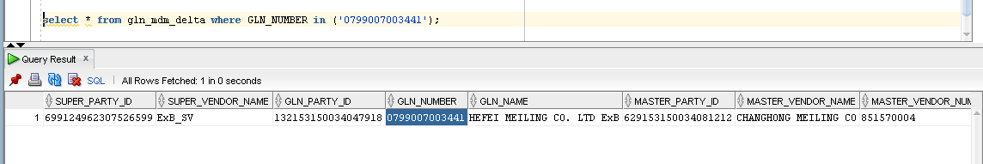

Master_Status –‘1’ represents Super Organization – ‘Active’

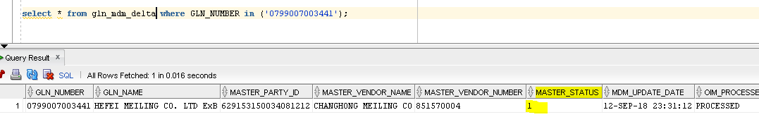

1. The below screenshot shows that the Temp VSA details are null in the **“GLN_staging”** hence the record needs to be processed manually.

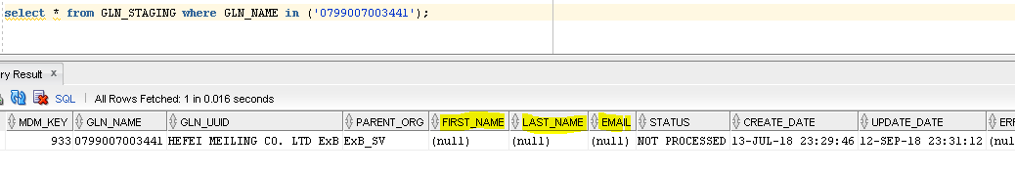

Once an Incident is raised to add the Temp VSA details . Take the First name, Last name, Email ID from the incident and manually update in the DB using update query:

Update GLN_Staging set First_name=’xxxxxx’ ,Last_name =’xxxxxxx’ , Email=’xxxxxxxxx’ where GLN_Name=’xxxxxxx’;

**Vendor Registration Issues**

Once any user got invited into Vendor OIM, User will get Invite/registration link to their registered email. Users need to fill the form using the invite link to provision the user account in Vendor system. Below are the different types of errors users will get.

1. 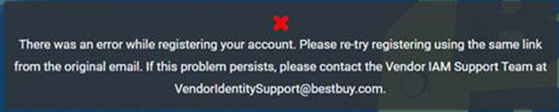

2.

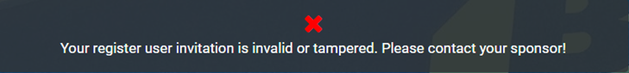

3.The Email is already exist.

**Solution steps.**

1.Need to check in invite det table with the email.

select * from usr_inv_det where usr_email_id like '%liberty@widecotrans.com%';

If you found multiple records for same Org, need to remove additional entries using md5_hash_key.

delete from usr_inv_det where md5_hash_key='26fb012bfbc5253f5b20ed4d2dbacf6e' and status='EXPIRED'

There should be one entry with ‘PENDING’ state.

If we have single entry with ‘PENDING’ state and user is getting above error. It should be a cache issue. Need to inform the user to close all browsers which are opened the invite link then clear cache and try to fill the form from new browser window.

2.This error will occur when the invite is in ‘EXPIRED’ state. Normally the invite will expire within 30 days from the generation date. Need to check the invite status in invite det table and update the status as ‘REINVITE’.

update usr_inv_det set status='REINVITE' where md5_hash_key='7b804d095b80cf7d88eb7393d7de05f7';

3.This error will occur where the account is already exist in the system with same email with TEMPID. Need to update the email in USR table to invite the same email.

update usr set usr_email='liberty@widecotrans.com_old' where usr_login in ('VY409969')

Note: We need to update the email back for the TEMPID if the user wants to use the same for different purpose.

**Temp VSA Registration Issues**

The TempVSA account will be created automatically for a VSA when ever we add a new Organization in the system. The VSA will be notified by a TempVSA account to maintain the Org. To invite new Users and VSA’s to that new Org, the TempVSA account need to convert as a permanent VSA by inviting the VSA account. Alternately the Sponsor can promote the TempVSA to VSA.

Some time system will not allow the same email while inviting to convert from TempVSA to Permanent VSA. We need to update the TempVSA account email with _old to accept the invite.

update usr set usr_email='liberty@widecotrans.com_old' where usr_login in ('VY409969')